Dialog - SSO Manual

For Azure Active Directory

# Step 1

Log in to https://portal.azure.com/ and go to “Azure Active Directory” in the sidebar. The sidebar may be folded/closed.

# 

# 

# 

# Step 2

Go to “App registrations” in the sidebar and click on “New registration”

# 

# Step 3

Create a new registration. Complete the following fields:

* Name: the application name that users will see. Enter “Dialog” here unless the application is internally known under a different name.
* Supported account types: this is organization dependent and must be filled in yourself.
* Redirect URI: the Dialog URLs that Azure AD allows. These are required for the SSO handshake. Enter “https://api.dialog.nl/api/sso/openidconnectcallback” here.

Save these changes.

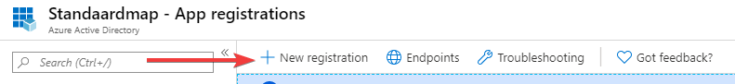

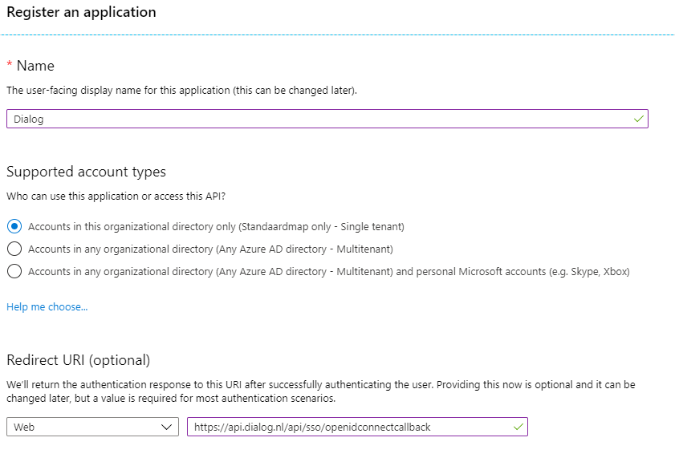

# 

# Step 4

Go to the app registration for further setup. Additional Redirect URIs can be set under “Authentication”.

Set the following uri's:

* <https://api.dialog.nl/api/sso/openidconnectcallback>
* <https://acceptance-api.dialog.nl/api/sso/openidconnectcallback>

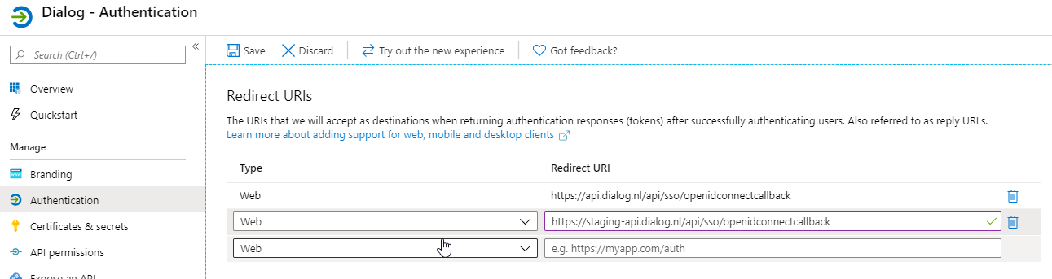

# Step 5

Go to “Branding” and set the name, logo, home page url and privacy statement url. Save the changes.

* Dialog
* <https://app.dialog.nl>
* <https://api.dialog.nl/privacy/privacy-declaration-en.pdf>

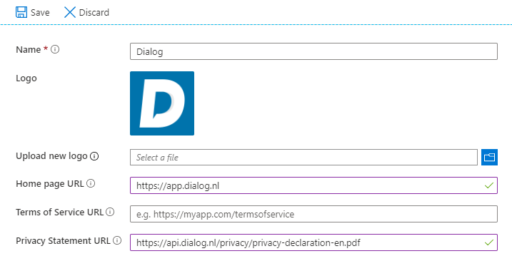

# Stap 6

Go to “API permissions” and click on the button “Grant admin consent”. This gives the app registration permission to access profile information of the users.

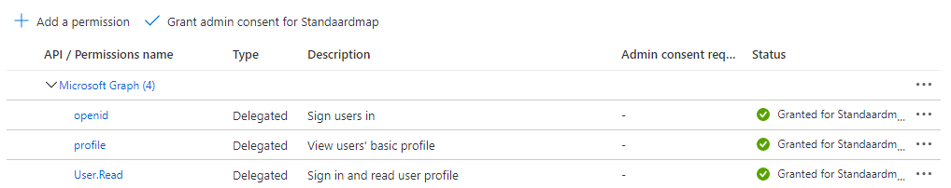

# Step 7

Go to “Certificates & secrets” and create a secret.

# Step 8

Collect the following information with the available information from the app registration. Information such as the directory / tenant ID can be found on the overview of the app registration.

| Category | Answer |
| --- | --- |
| Tenant ID |  |
| Client ID |  |
| Client secret |  |
| Domain | e.g. dialog.nl / dialog-hr.nl |

# Step 9

Create a test account in Azure AD so that the SSO can be tested before it goes live. Send the login details of this account together with the information from step 8 to marco@dialog.nl. Occasionally, test accounts do not function properly because an email claim is not sent in the identity token. Check whether the account is linked to an exchange mailbox.

First of all, we tested whether all claims are properly sent on the acceptance server, optionally the involved party can also test it themselves and finally it is activated on the production server.